## Bidding Calculator

### Project Goals:

1. User is able to enter cost of goods sold and overhead costs to determine the proper amount to bid for a project/contract
2. Row #2 of Cost Of Goods Sold is a button that allows the user to add a new row to costs of goods sold
   1. When the `add row` button is clicked, a new set of input boxes is added to the previous input row and the add button is moved down a row
   2. Example

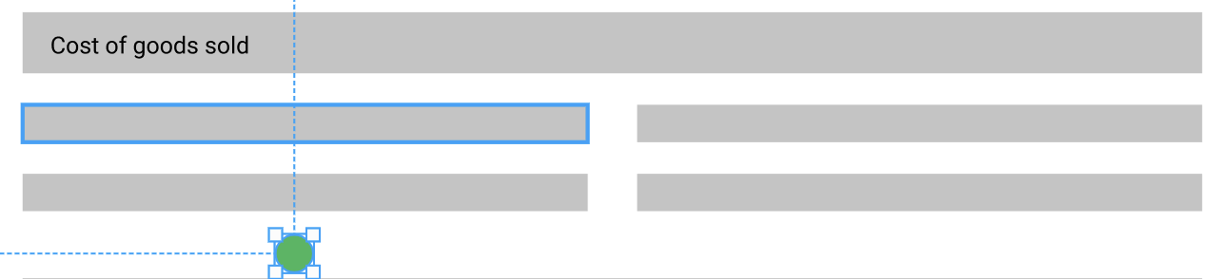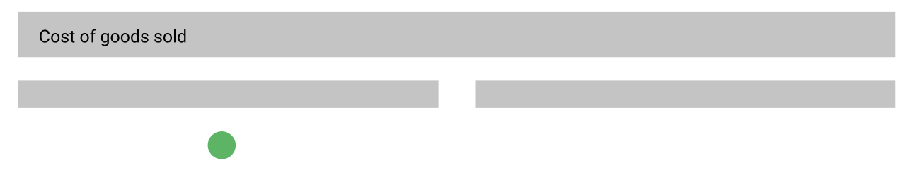

1. The Overhead values will be organized into collapsible categories
2. **TOTAL OVERHEAD** cell will be the sum of all of the overhead inputs
3. **TOTAL COST OF GOODS SOLD** cell will be the sum of all COGS cells
4. **PROFIT** is an input cell, restricted to #s
5. **TOTAL** cell is the **SUM** of **TOTAL OVERHEAD, TOTAL COST OF GOODS SOLD,** and **PROFIT** cells
6. The next step in this project would be expanding to store this data in a database table, so what we want to see from this interview project is how you, as a developer, organize the project to allow it to be easily extended to allow for modification by yourself, or another developer. This means well documented code with a well-defined logical flow and structure.